World History

The Paris Peace Conference & Versailles Treaty

Background
In August 1914 World War I officially began. Leaders of involved nations believed the war was going to be short, and their troops would be home to celebrate Christmas in December. Underestimating the technological change to warfare as a result of industrialization, they were soon proven wrong. The two-front war between the Allies and the Central Powers quickly became a stalemate and war of attrition. More men were sent to the trenches, and on the home front all civilians were impacted by a total war economy. In 1917, two events shaped the course of the war: The Russian Revolution pulled Russia out of the conflict, but the United States was also pulled in on the side of the Allies. This entrance tipped the balance of war greatly in favor of the Allies thanks to the surge of armaments produced in the highly industrialized U.S. economy. In 1918, under the strain of food shortages and workers’ strikes, the German government was overthrown and an armistice (cease fire) was declared on November 11, 1918. The following year the Allied Powers met at the Paris Peace Conference to dictate the terms of peace laid out in the Versailles Treaty.

Historical Literacy: Geography
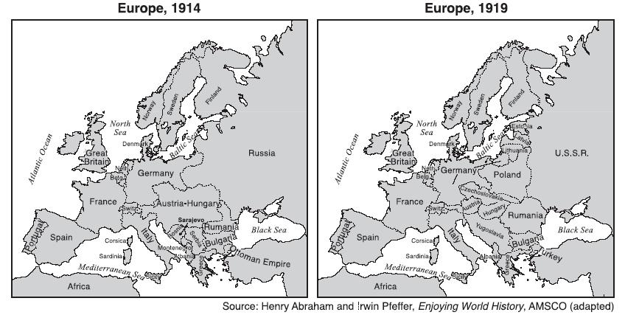
- Identifying Main Ideas: The region of Europe most affected by the territorial changes made at the Paris Peace Conference was:
  - Western Europe
  - Eastern Europe
  - Mediterranean Europe
  - Northern Europe

- Drawing Inferences: Based on the maps, a historian might infer that the goals of the Paris Peace Conference were all of the following EXCEPT:
  - To punish the Central Powers by reducing or breaking apart their territory
  - To better organize the nationalities of Eastern Europe by giving them independent states
  - To greatly reward the Allied powers for their victory with newly acquired territories
  - To “buffer” the spread of communism by placing new “buffer states” between the USSR and Western Europe

Source Evaluation: Primary Sources

Source 1: Excerpts from U.S. President Woodrow Wilson’s speech to Congress that outlined his “Fourteen Points” proposal for how to end the war, delivered January 8, 1918.

We entered this war because violations of right had occurred… What we demand in this war…is that the world be made fit and safe to live in; and particularly that it be made safe for every peace-loving nation which, like our own, wishes to live its own life, determine its own institutions, be assured of justice and fair dealing by the other peoples of the world as against force and selfish aggression…The program of the world's peace, therefore, is our program; and that program…as we see it, is this:

I. Open covenants of peace, openly arrived at, after which there shall be no private international understanding of any kind but diplomacy shall proceed always frankly and in the public view.

IV. Adequate guarantees given and taken that national armaments will be reduced to the lowest point consistent with domestic safety.

V. A free, open-minded, and absolutely impartial adjustment of all colonial claims, based upon a strict observance of the principle that in determining all such questions of sovereignty the interests of the populations concerned must have equal weight with the equitable claims of the government whose title is to be determined.

VIII. All French territory should be freed and the invaded portions restored, and the wrong done to France by Prussia in 1871 in the matter of Alsace­Lorraine, which has unsettled the peace of the world for nearly fifty years, should be righted…

X. The peoples of Austria­Hungary, whose place among the nations we wish to see safeguarded and assured, should be accorded the freest opportunity of autonomous development.

XIII. An independent Polish state should be erected which should include the territories inhabited by indisputably Polish populations…

- Identifying Main Ideas: According to President Wilson, the United States joined the Allied Powers in World War I because:
  - German aggression against the United States forced them to declare a side
  - The war was damaging the U.S. economy and threatening their economic markets
  - Aggression of the Central Powers flooded the U.S. with Eastern European immigrants
  - The rights and safety of peoples around the world was being violated by selfish aggression

- Identifying Main Ideas: Wilson suggests resolutions to all of the following issues that caused World War I, EXCEPT:
  - Nationalism in Eastern Europe
  - The secret system of international alliances
  - Competition over colonies in the Age of Imperialism
  - The denial of natural rights among peoples that desire them

- Identifying Main Ideas: What does President Wilson mean by, “the peoples of Austria-Hungary…should be accorded the freest opportunity for autonomous development?”
  - Austria-Hungary had the right to retaliate for the assassination of Franz Ferdinand
  - Austria-Hungary should break its alliance with Germany to end the war
  - The various cultures in Austria-Hungary have the right to their national independence
  - Austria-Hungary has the right to decide their own national policy without interference from the international community

- Drawing Inferences: Given the context in which this speech was given, President Wilson most likely believed that:
  - The Central Powers were close to winning the war, and Congress had to be warned
  - The Allies would win the war, and the U.S. would have great power at the peace conference
  - After the war, the U.S. should be neutral and let European powers settle their own issues
  - The U.S. was not right to join the conflict, and Congress should declare neutrality

Source 2: Excerpts from the Versailles Treaty, presented by the Allied Powers and signed by Germany at the end of the Paris Peace Conference on June 28, 1919.

Article 42. Germany is forbidden to maintain or construct any fortifications either on the left bank of the Rhine or on the right bank to the west of a line drawn 50 kilometres to the East of the Rhine.

Article 45. As compensation for the destruction of the coal mines in the north of France and as part payment towards the total reparation due from Germany for the damage resulting from the war, Germany cedes to France in full and absolute possession, with exclusive right of exploitation, unencumbered and free from all debts and charges of any kind, the coal mines situated in the Saar Basin....

Alsace­Lorraine. The High Contracting Parties, recognizing the moral obligation to redress the wrong done by Germany in 1871 both to the rights of France and to the wishes of the population of Alsace and Lorraine, which were separated from their country in spite of the solemn protest of their representatives at the Assembly of Bordeaux, agree upon the following....

Article 119. Germany renounces in favor of the Principal Allied and Associated Powers all her rights and titles over her overseas possessions.

Article 159. The German military forces shall be demobilised and reduced as prescribed hereinafter

Article 231. The Allied and Associated Governments affirm and Germany accepts the responsibility of Germany and her allies for causing all the loss and damage to which the Allied and Associated Governments and their nationals have been subjected as a consequence of the war imposed upon them by the aggression of Germany and her allies…

…The Allied and Associated Governments, however, require, and Germany undertakes, that she will make compensation for all damage done to the civilian population of the Allied and Associated Powers and to their property during the period of the belligerency of each as an Allied or Associated Power against Germany.

- Identifying Main Ideas: As a result of the Treaty, France received:
  - Access to important coal mines and their former territory of Alsace-Lorraine
  - A transfer of all German overseas colonies to French possession
  - Fortifications on the Rhine to protect from a potential German threat in the future
  - Funding for an enlarged military to protect against a potential German threat in the future

- Identifying Main Ideas: Germany is held accountable and punished for World War I in all of the following ways, EXCEPT:
  - Germany is required to give up access to raw materials needed for industrialization
  - The German military is reduced to a prescribed size and limited to prescribed regions
  - The German government is required to pay for the war and the damage it caused
  - Germany is divided into four distinct states to weaken to the government, military, and economy

- Identifying Main Ideas: In addition to punishing Germany for World War I, the Versailles Treaty also:
  - Accounted for, and corrected the abuses of, past German aggression against France
  - Ended the age of imperialism by declaring all colonies independent
  - Gave France the right to exploit the German people
  - Encouraged all European states to demobilize their militaries to prevent future war

- Synthesizing Evidence: Which of President Wilson’s proposals in the “Fourteen Points” speech are actually addressed in this passage of the Versailles Treaty?
  - The call to “adjust colonial claims” by including the opinions of colonized peoples
  - The demand that all diplomacy take place openly and without secrecy
  - The suggestion that peoples in Austria-Hungary be allowed their own national governments
  - The insistence that traditional French territories be restored

- Drawing Inferences: Based on the terms of this treaty, which of the following was most likely the perspective held by the Allied Powers regarding the origins of World War I?
  - The conflict was primarily a result of unchecked nationalism in the Balkans, and was therefore caused by Austria-Hungary’s failure to punish Serbia
  - While the Serbian Black Hand was primarily at fault for causing a war, Germany was the only power wealthy enough to pay for damages, and was blamed as a result
  - Germany’s early aggression in offering Austria-Hungary a “blank check” and enacting the Schlieffen Plan was most responsible for turning a local conflict into a global conflict
  - The cause of the war was rooted in long-term tensions over colonies, which encouraged European militarization and nationalism

Source 3: A political cartoon from 1919 depicting Georges Clemenceau, the delegate of France, at the Paris Peace Conference
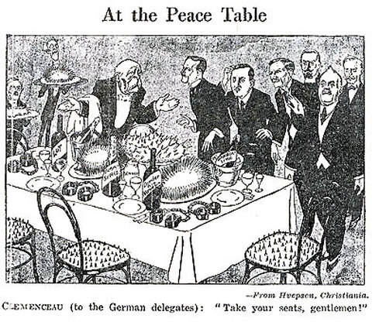

- Identifying Main Ideas: Most notably, the Germans approach the table which represents:
  - A lavish meal
  - French courtesy
  - Disguised traps
  - The spoils of war

- Drawing Inferences: The political cartoonist implies which of the following about the Paris Peace Conference?
  - France was not actually interested in peace, but solely in punishing Germany
  - The delegates used the conference as an excuse for lavish parties
  - The French delegation was forced, again, to serve the interests of the Germans
  - The conference was successful at resuming diplomatic courtesy between nations

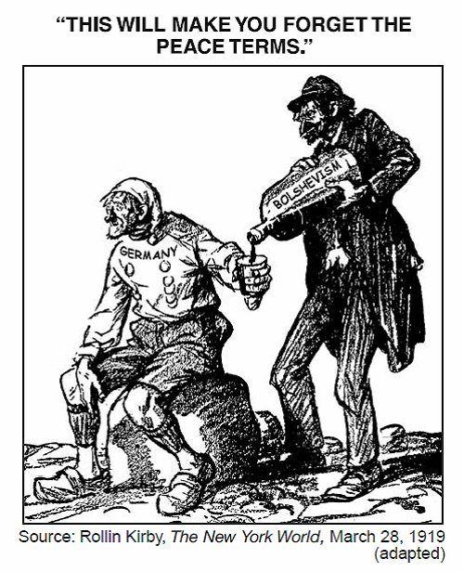
Source 4: Two political cartoons comment on the impacts of the Versailles treaty. The cartoon on the left is from 1919, and on the right is from 1930.
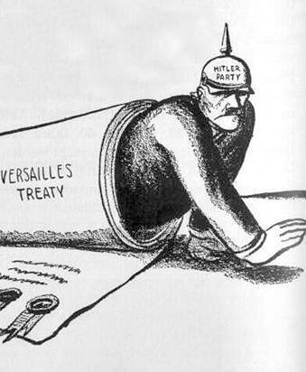

- Identifying Main Ideas: The artist who created the political cartoon on the left is suggesting that:
  - Germans will accept Bolshevism to cope with the harsh terms of the Versailles Treaty
  - Russian Bolshevism was the actual cause of Germany’s defeat
  - The Paris Peace Conference was manipulated by Russian Bolsheviks
  - The Russian Bolsheviks are most responsible for the cause of World War I

- Drawing Inferences: BOTH cartoons suggest that the terms of the Versailles Treaty:
  - Fairly punished Germany for World War I
  - Unfairly blamed Germany for causing the outbreak of war
  - Were so harsh on Germany that it caused the rise radical political ideologies
  - Were secretly written by Hitler and the Bolsheviks

Source Evaluation: Secondary Sources

Source: Historian Wolfgang Mommsen, from the University of Dusseldorf in Germany (PBS.org)

All of a sudden, we are confronted with what the bulk of the Germans considered an entirely unjust treaty. So resistance against this Treaty was enormous. I think that the strongest resistance concerned the territorial concessions in the East. Nobody was willing to concede that much territory to the new Polish State. Nobody was willing to accept willingly the system of reparations.

The Treaty of Versailles created a political climate in Germany in which the right put all the blame on everything that went sour, onto the Treaty and the lost war. And that created this climate in which many people then began to think one had to fight the war once again.

- Identifying Main Ideas: In Mommsen’s opinion, the term of the Versailles Treaty that were most harsh to Germans was:
  - The forced reparations (repayments) for war costs and damages
  - The limitations on the size of their military and defensive fortifications
  - The loss of their overseas colonies and French territories
  - The creation of new Eastern European states using former German land

- Making Historical Claims: Which of the following statements best summarizes the historian’s claim about the Versailles Treaty?
  - While German leaders found the treaty entirely unjust, most Germans felt it was fair
  - The Allied Powers should held responsible for the suffering that the Treaty brought upon the Germans
  - The Treaty was used as a scapegoat in German politics, and led to a German desire for revenge
  - The terms of the Treaty drove Germany into great financial crisis, which made Germans desperate for change

