World History
Final Exam Case Study
Napoleon
Background
During the French Revolution, France’s armies were surprisingly successful on the international battlefield. Despite being poorly equipped for battle, the soldiers’ nationalism and strong leadership – like that of General Napoleon Bonaparte – brought victory abroad despite increasing chaos at home. Napoleon Bonaparte became a French national hero for his military conquests in Italy, and in 1799 he used the loyalty of his troops to seize control of the French government by force (a coup d’etat). He ruled the country with dictatorial powers, and in 1804 he was crowned Emperor of France with the support of the public. During his time in power, Napoleon greatly enlarged the French Empire and restored order at home with a new legal system. Eventually his troops were defeated in 1815 by an international coalition of British, Prussian, and Austrian troops at the Battle of Waterloo. Napoleon’s historical legacy – as a conqueror or a reformer – is greatly debated.

Historical Literacy: Geography
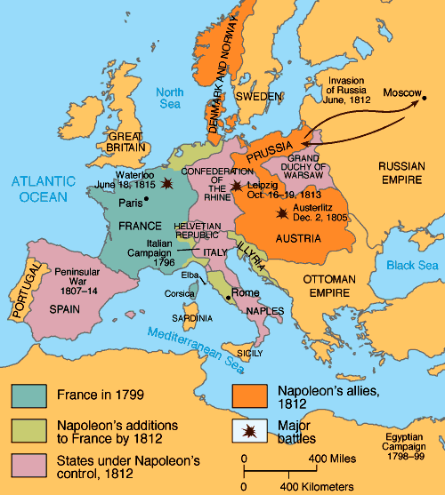

The Growth of Napoleon’s French Empire, 1799-1812

- Identifying Main Ideas: By 1812, Napoleon had conquered all of the following regions EXCEPT:
  - The southern coast of the North Sea and English Channel
  - The Italian Peninsula
  - Great Britain
  - Most of the German States

- Drawing Inferences: All of the following are accurate inferences one could draw from this map EXCEPT:
  - Napoleon’s goal was to conquer and control all of Europe
  - Napoleon was willing to make diplomatic alliances to achieve his goals
  - Napoleon attempted to invade and conquer Russia
  - Napoleon led an accomplished navy and won many sea battles
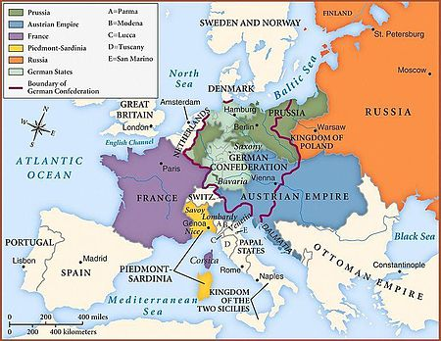

After the defeat of Napoleon, the leaders of Europe met at an event known as the Congress of Vienna. This is a map of Europe after the Congress of Vienna, 1815.

- Identifying Main Ideas: After the defeat of Napoleon, all of the following changes were made at the Congress of Vienna EXCEPT:
  - France was divided between the British, Austrian, and Prussian Empires
  - Austria, Prussia, and Russia all gained territory in Europe
  - France was nearly restored to its original, pre-Napoleon borders
  - Spain, The Netherlands, and the Italian Peninsula were restored to independence

- Drawing Inferences: Based on this evidence, what is the best inference on can make about the purpose of the Congress of Vienna?
  - It meant to harshly punish France for Napoleon’s aggression.
  - It intended to reward those that defeated Napoleon and restore a balance of power
  - It sought to unify Europeans under one centralized government
  - It aimed to prevent further French aggression by dividing the country between victors

Source Evaluation: Primary Sources

Source 1: Excerpts from the Napoleonic Code, Napoleon’s Constitution adopted in France in 1804.

Article 7. The exercise of civil rights is independent of the quality of citizen, which is only acquired and preserved comfortably to the constitutional law.

Article 8. Every Frenchman shall enjoy civil rights.

Article 217. A wife…cannot give, alienate, pledge, or acquire by free or chargeable title, without the concurrence of her husband in the act, or his consent in writing.

Article 545. No one can be compelled to give up his property, except for the public good, and for a just and previous indemnity.

- Identifying Main Ideas: All of the following are guaranteed to citizens in the Napoleonic Code EXCEPT:
  - The right to own and keep property
  - Equality regardless of race, gender, or religion
  - The protection of rights by a constitution
  - For all men, equality under the law

- Drawing inferences: Which is the best inference about the Napoleonic Code?
  - The Code restored Absolutism, undoing the reforms of the French Revolution
  - The Code made all people citizens who enjoyed equal rights under the law
  - The Code embraced Enlightenment values while upholding traditional gender roles
  - The Code rejected Enlightenment values and restored a feudal social hierarchy

- Drawing Inferences: The ideas of which of the following Enlightenment Philosophes is represented in this excerpt of the Napoleonic Code?
  - John Locke
  - Mary Wollstonecraft
  - Voltaire
  - Baron de Montesquieu

Source 2: Letter from Napoleon Bonaparte to his brother, Jerome Napoleon, who was given the title of King of Westphalia (a German region of Prussia) after it was conquered by French armies, 1807.

I enclose the Constitution for your Kingdom…You must faithfully observe it….

Don’t listen to those who say that your subjects are so accustomed to slavery that they will feel no gratitude for the benefits you give them…men of no rank, but of marked ability, shall have an equal claim upon your favour and your employment, and that every trace of serfdom, or of a feudal hierarchy between the sovereign and the lowest class of his subjects, shall be done away…I want your subjects to enjoy a degree of liberty, equality, and prosperity…

What people will want to return under the arbitrary Prussian rule, once it has tasted the benefits of liberal administration? In Germany, as in France, Italy, and Spain, people long for equality and liberalism.

- Identifying Main Ideas: In this letter, Napoleon is asking his brother to:
  - Impose harsh rule on German people after their conquest
  - Conquer Italy and Spain after he is done imposing laws on Germans
  - Implement his law code in Germany to bring equality under the law
  - Uphold the system of serfdom and the feudal hierarchy existing in Prussia

- Identifying Main Ideas: Which of the following accurately describes a “liberal administration,” or “liberalism,” based the text?
  - Respecting the individual, civil rights of individuals
  - An Enlightenment-inspired political system
  - Valuing equality before the law
  - All of the above

- Drawing Inferences: Which is the most accurate inference about Napoleon as a conqueror based on this source?
  - After conquest, Napoleon would free the slaves and let them choose their own liberal governments.
  - After conquest, Napoleon placed family members on foreign thrones so they would implement his liberal reforms.
  - Napoleon was a brutal conqueror who enslaved the peoples of Germany, Italy, and Spain.
  - Napoleon was an ineffective conqueror who relied on assistance from his family members to maintain power.

Source 3: Letter from Napoleon Bonaparte to Joseph Fouché, minister of police. April 22, 1805.
Repress the journals a little; make them produce wholesome articles. I want you to write to the editors of the…newspapers that are most widely read in order to let them know that the time is not far away when, seeing that they are no longer of service to me, I shall suppress them along with all the others…Tell them that the…Revolution is over, and that there is now only one party in France; that I shall never allow the newspapers to say anything contrary to my interests…
- Identifying Main Ideas: According to this letter, which civil right is Napoleon repressing?
  - free speech
  - private property
  - freedom of religion
  - assembly

- Drawing Inferences: What is Napoleon’s intention in limiting this civil right?
  - To return France to an Absolute Monarchy
  - To punish writers and journalists for their role in the Revolution
  - To keep people uninformed about his losses on the battlefields
  - To control public opinion and, therefore, maintain support for his authority

- Making Historical Claims: Based on ALL the above sources provided, which is the most accurate claim a historian can make about Napoleon?
  - Napoleon sought to destroy the accomplishments of the French Revolution, but failed to do so.
  - Napoleon’s goal was to liberate Europeans by spreading the ideals of the Enlightenment and Republicanism across the continent.
  - Napoleon was a power-hungry conqueror who wished solely to increase his strength at any cost to those he conquered.
  - Napoleon was an able conqueror who was willing to implement Enlightened reforms as long as they didn’t limit his personal power.

Source Evaluation: Secondary Sources

Source: Michael V. Leggiere, historian, “Enlightened Despotism Comes to France.”

Napoleon's domestic program cannot be categorized as that of an enlightened revolutionary, for he never believed in the revolutionary concept that sovereignty resided with the people. Nor can his domestic policies be likened to those of a power-hungry tyrant. Instead, Bonaparte provided France with a form of enlightened despotism masked by a façade of democratic ideals…
In short, Napoleon—the child of the Enlightenment and not the child of the Revolution—succeeded in providing rational order to the chaos, anarchy, and confusion of the French Revolution. He instituted sweeping reforms in education, administration, and finance that still exist today. He saved the state from bankruptcy, healed the rift with the Catholic Church, and ended a bloody civil war. His most comprehensive achievement, the Napoleonic Code, made law uniform throughout France and protected the individualism established by the Revolution by forever abolishing custom and privilege…An incomparable servant of the state, Bonaparte's impact on the national institutions of France can still be seen today. True to the tenets of enlightened despotism, Napoleon strove to improve the state community as a whole by giving the people what they needed, yet he never felt inclined to govern according to their will…If, toward the end of the French Empire, certain aspects of Bonaparte's domestic program did become despotic, it is not because Napoleon was a power-hungry tyrant. Instead, the reason is because Napoleon himself was a despot. He never held out the prospect of embracing republican democracy and surrendering his sovereignty to the will of the people…

- Identifying Main Ideas: All of the following enlightened accomplishments are attributed to Napoleon in this source, EXCEPT:
  - A law code that protected individualism and legal equality
  - Reforming education, administration, and finances of the French state
  - Restoring order to and traditional religion to France
  - Governing according to the sovereign will of the people

- Identifying Main Ideas: Which of the following is the label that this historian gives to Napoleon?
  - A power-hungry tyrant
  - A child of the Revolution
  - An enlightened despot
  - An enlightened revolutionary

- Identifying Main Ideas: Based on the source context, a “despot” is a leader who:
  - Holds absolute power
  - Enacts enlightened reforms
  - Spreads revolutionary ideals
  - Rules on behalf of the people who are sovereign

- Making Historical Claims: Which of the following statements best summarizes the author’s thesis about Napoleon?
  - Napoleon was a ruler with absolute power, but used that power to reform government in enlightened ways.
  - Napoleon was a true child of the Enlightenment and Revolution, but failed to restore France to a Republic despite his attempts.
  - Napoleon should be best known for his military conquests, not his domestic reforms.
  - Napoleon was a power-hungry tyrant who only used enlightened reforms to seem just.

