World History
Enlightenment

Enlightenment Propaganda - Due – 12:15 p.m.

Goal: I can synthesize the ideas of the enlightened thinkers by creating a propaganda ad with a message that relates to a controversial topic in today’s society.
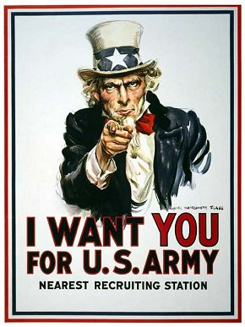

What is propaganda? Propaganda is the presentation of information from a particular perspective, which tries to influence people to think a certain way. At the right is an example:

To sum up the enlightenment, your PAIR will complete the following (worth 20 points):

1. (10 points): Create a news brief that expresses a particular point of view about ONE contemporary issue, such as:

- Occupy Wall Street (Occupy Chicago)
- Rising taxes for lower and middle class families
- High rate of unemployment for teenagers
- Problems with underage drinking
- Gun Control
- Censorship in Media
- Laws against piracy (ex: SOPA)
- Political corruption (spending government money for the wrong reasons, the president has too much power, Congress cannot pass any laws)
- Capital punishment (abolish the death penalty?)
- Global warming (harm or help the environment?)
- Driving while under the influence of alcohol or drugs
- Equality under the law (same-sex marriage)
- Monitoring your cell-phone (wiretapping)
- Other ideas? – Ask me first

Construct the news brief (at least two paragraphs long) where you identify the specific problem and you propose a specific solution. When writing your brief, YOU MUST report from the perspective of ONE of the following philosophes below:

- Hobbes
- Locke
- Montesquieu
- Rousseau
- Voltaire

2. (10 points): Create a visual similar to the style seen on this page that best represents the issue your group is writing about and the point of view based the enlightened thinker you choose to use. Refer to your class/reading notes, the art interpretation, the philosopher chart, the primary sources from the American Revolution and any other handouts to help you.

