World History
Unit 2: Classical Empires
Skill: Art Interpretation

Imperial Art:
Roman Art as an Empire-Building Tool

Description Review: Art Interpretation Vocabulary

Subject: the “topic” of the work of art

Focal Point the image your eye is drawn to first

Color the use of hues to draw attention and add meaning

Light the use of illumination to add meaning and emphasis

Analysis: Greco-Roman Art

CLASSICAL STYLE (CLASSICISM):
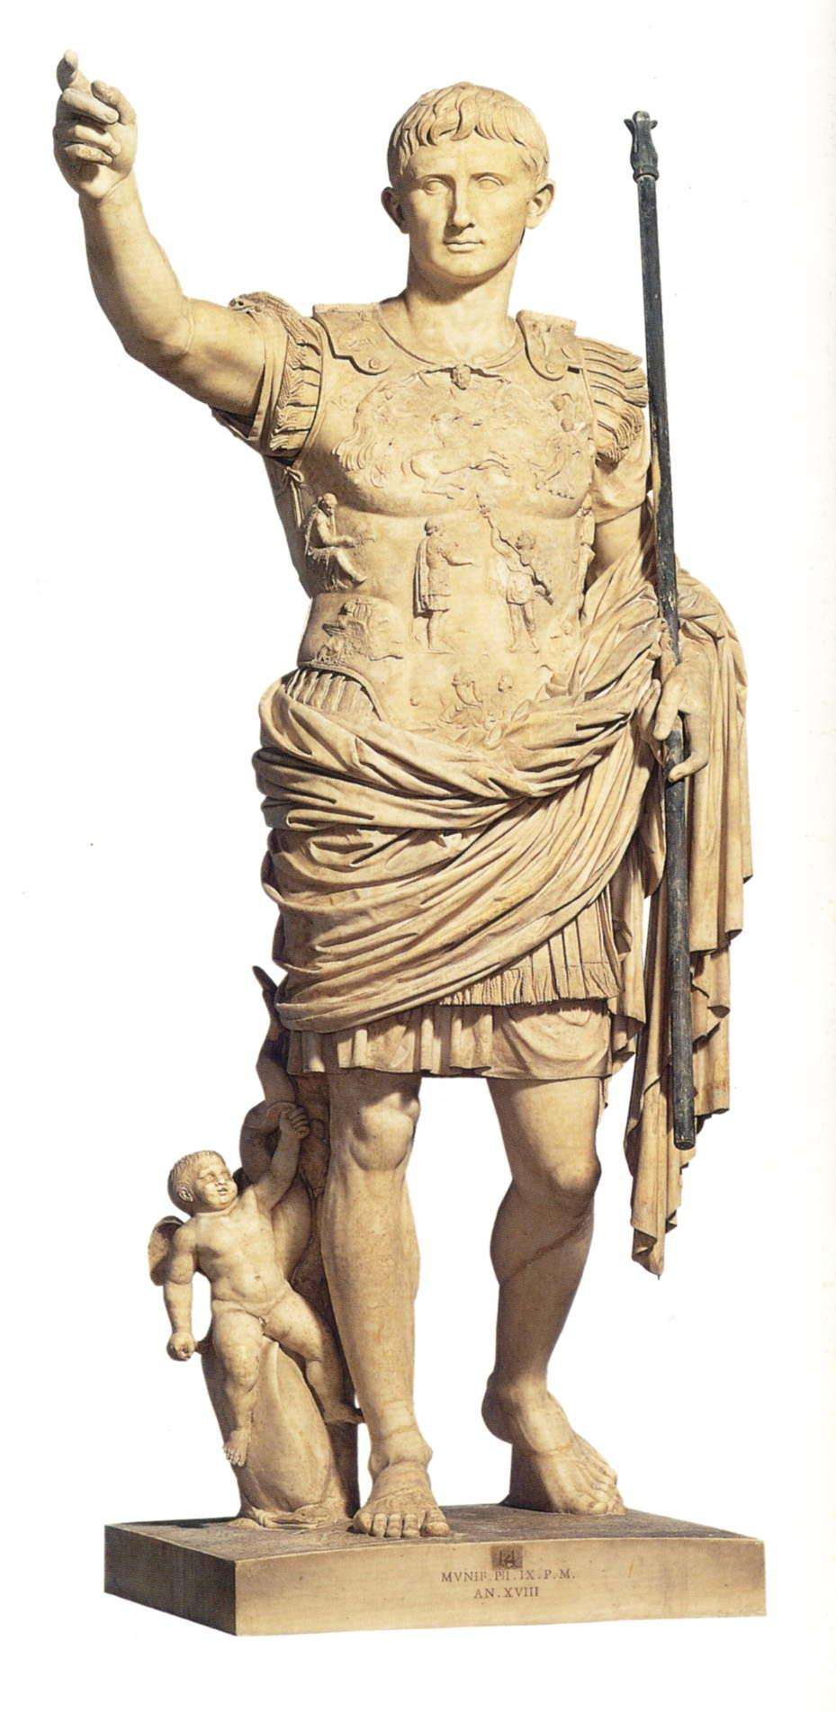
Balance:

Proportion:

Realism:

Idealism:

Interpretation Review: Describe the Art
- Let’s review the standard we reached through consensus and examples (next page)

Contextualize: Making Historical Connections
- What does it mean to contextualize?
- How would a historian (or student of history) show his or her ability to contextualize a work of art?

